SQL Query to create table employee :

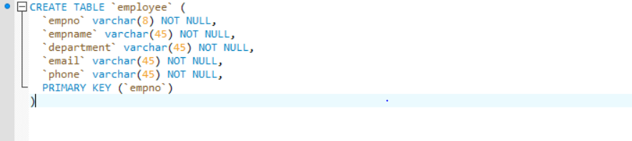

Employee table :

